Phase 2 · Develop
Exercise 5: The API Surface: FastAPI Endpoints
Dev cycle | Develop (API)
CC features | Build loop, running the live server, validating in the Swagger UI (/docs), pydantic schemas
Time | 40 min
You produce | A running FastAPI app with create / list / get / approve / reject endpoints

Objective
Stand up the API itself. You will generate pydantic schemas and routes, run the live server with Uvicorn, and validate every endpoint by hand in the auto-generated Swagger UI. This is the most satisfying exercise: by the end you have a clickable API.
Walk-through
1 | Generate request and response schemas
pydantic models define the API contract. Keep them separate from the ORM model so the wire format and the storage format can diverge cleanly.
Create app/schemas.py with pydantic v2 models: ExpenseCreate and ExpenseOut (with relevant fields). Add field validation

Type this prompt into Claude Code
Create app/schemas.py with pydantic v2 models: ExpenseCreate (description, amount_minor, currency, category, submitted_by) and ExpenseOut (all fields including id, amount_base_minor, status, created_at). Amounts are integer minor units. Add field validation: amount_minor must be positive, currency is a 3-letter code.
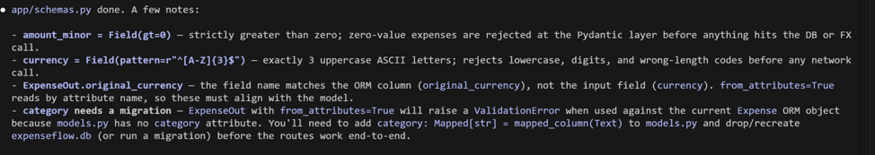
Create app/schemas.py with pydantic v2 models: ExpenseCreate and ExpenseOut (with relevant fields). Add field validation

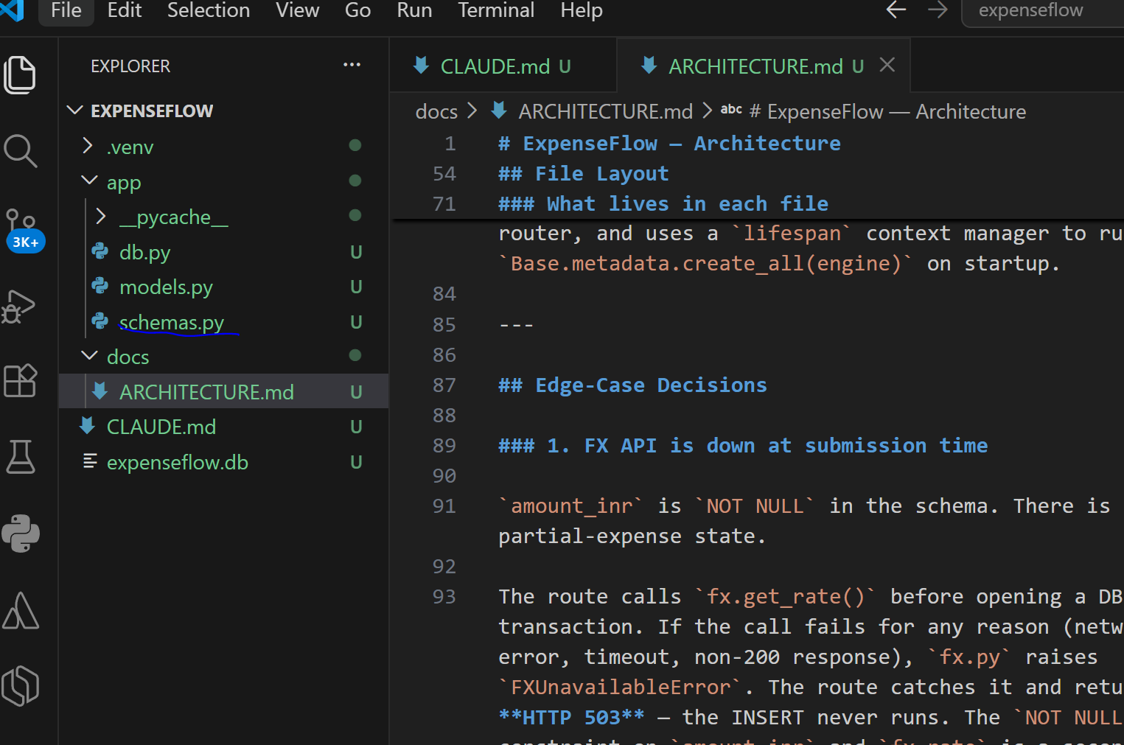

2 | Generate the routes and app entry point
Now the endpoints and the FastAPI app. Tell Claude to leave the FX conversion as a clearly-marked stub for now: amount_base_minor equals amount_minor. You will wire real conversion in Exercise 6.
Type this prompt into Claude Code
Create app/routes.py with an APIRouter and app/main.py with the FastAPI app that includes the router and calls init_db on startup. Endpoints from ARCHITECTURE.md: POST /expenses (create, status pending), GET /expenses (list, optional status and category query filters), GET /expenses/{id} (404 if missing), POST /expenses/{id}/approve, POST /expenses/{id}/reject. For now set amount_base_minor = amount_minor with a TODO comment marking where FX conversion goes. Use the get_db dependency.
VALIDATE Read the diff across app/main.py and app/routes.py. The TODO marker for FX conversion is present. Approve / reject set status and return the updated expense. Approve the changes.
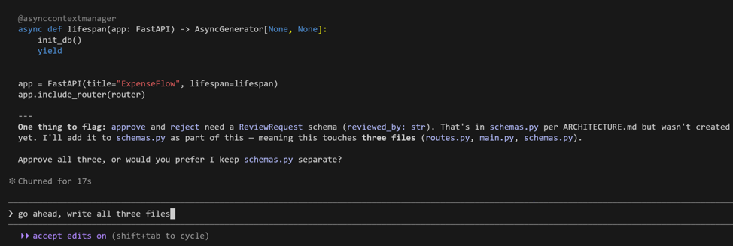
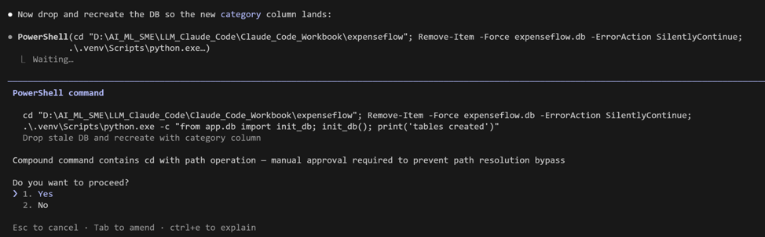
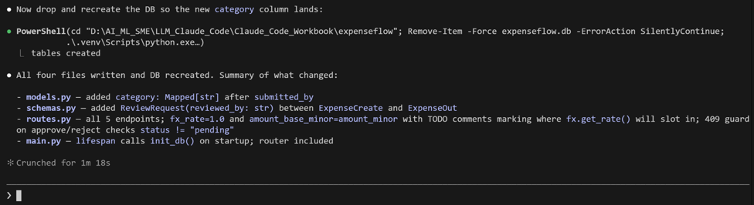
3 | Run the live server
Start Uvicorn with auto-reload. Leave this terminal running and open a second PowerShell tab for other commands.
Run in terminal
PS> python -m uvicorn app.main:app --reload
VALIDATE The terminal shows 'Uvicorn running on http://127.0.0.1:8000' and 'Application startup complete'. Any traceback here is your next prompt to Claude: paste it whole.
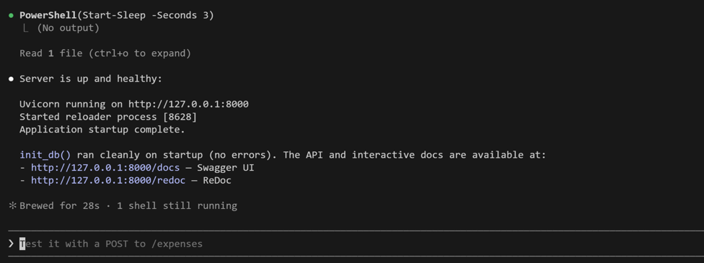

4 | Validate in the Swagger UI
FastAPI auto-generates interactive docs. Open them in your browser and exercise the API by hand. No code needed: this is the demoable surface.
Open in your browser
PS> http://127.0.0.1:8000/docs
VALIDATE All five endpoints appear. POST /expenses with a sample body returns 200 and a JSON expense with status 'pending' and an id. GET /expenses returns it in a list. GET on a missing id returns 404. POST .../approve flips status to 'approved'.
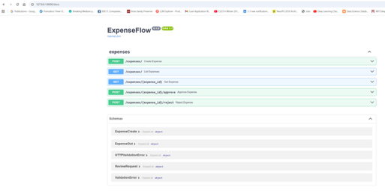

5 | Drive one full journey
Use 'Try it out' in Swagger to run the whole user journey end to end: submit, list, approve, confirm. This is your 60-second demo from the course.
Sample POST /expenses bodycases } (that is 2500.00 INR as paise).
Example #2
{
"description": "Flight to Bangalore",
"submitted_by": "alice",
"category": "travel",
"amount_minor": 15000,
"currency": "USD"
}

VALIDATE Submit returns id 1, status pending. Approve id 1 returns status approved. GET /expenses?status=approved returns exactly that expense. The core journey works.
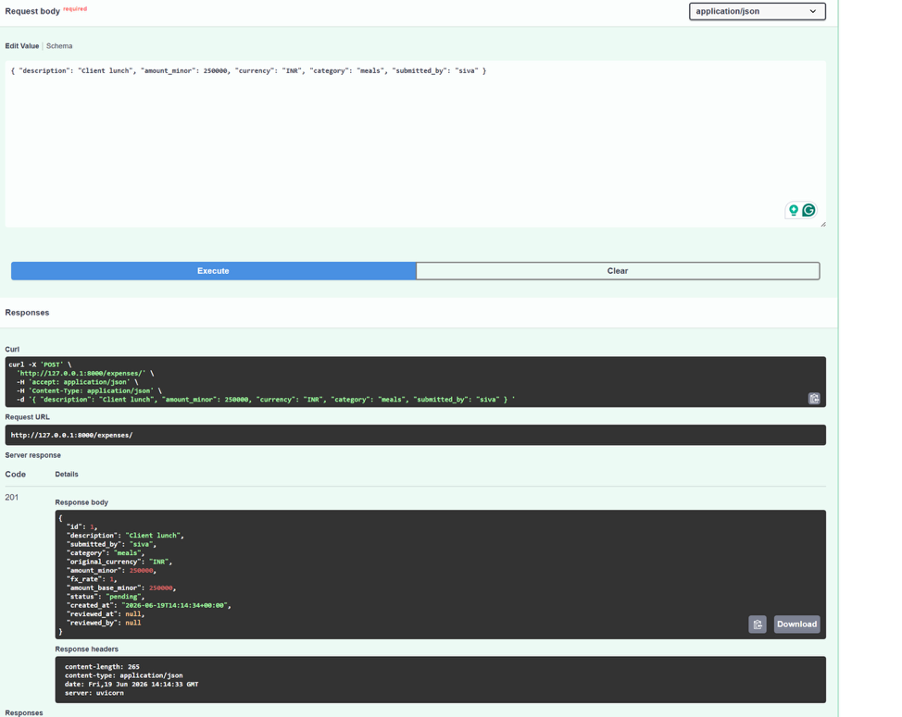

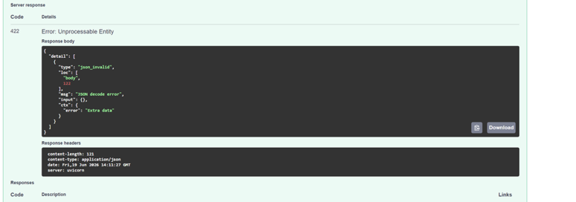
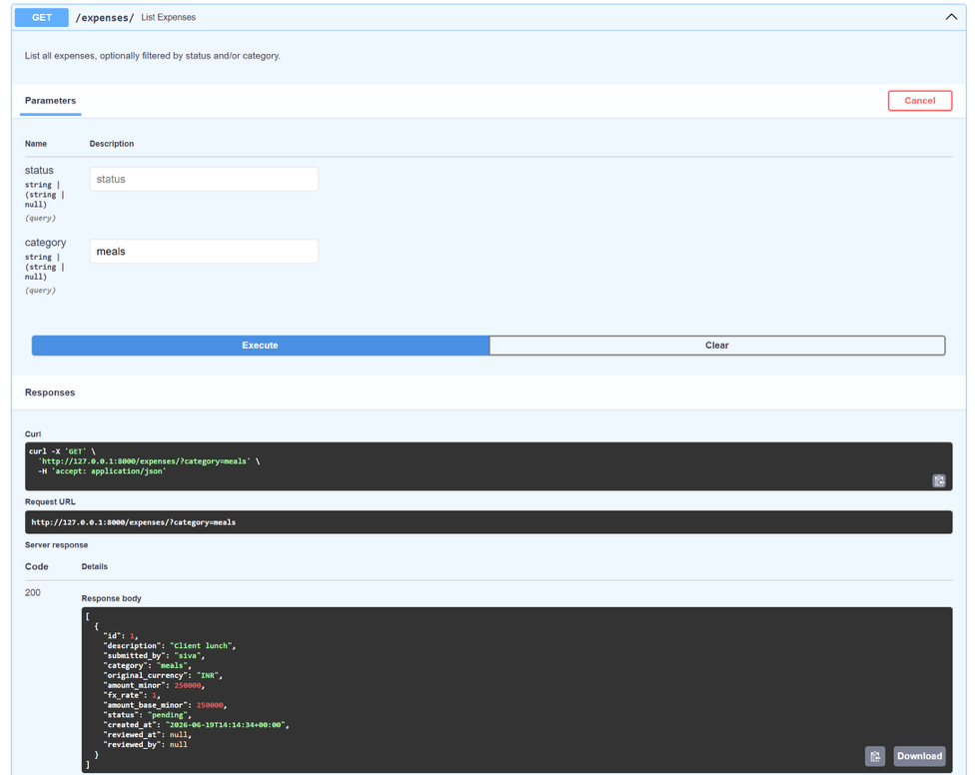
What success looks like
- Uvicorn serves the app and the Swagger UI lists all five endpoints.
- You ran the full submit -> list -> approve journey by hand without writing client code.
- The FX conversion is a clearly-marked TODO, deliberately deferred, not silently faked.
Common pitfalls (Windows and macOS)
- Port 8000 in use? Add --port 8001 to the uvicorn command and open /docs on that port.
- Auto-reload only watches code files. If you change CLAUDE.md or .env, restart the server manually.
- Keep the server terminal running. Run all other commands in a second terminal tab so you do not kill it.
Stretch goal
Ask Claude to add a GET /health endpoint that returns status ok and the row count of expenses. Health checks are the first thing any deployment platform asks for.

